Department of Electronics and Communication Engineering



PESIT- Bangalore South Campus

SSVEP Classification

Group Number: 31



BLOCK DIAGRAM



DEMONSTRATION

**Occipital**

**Lobe**

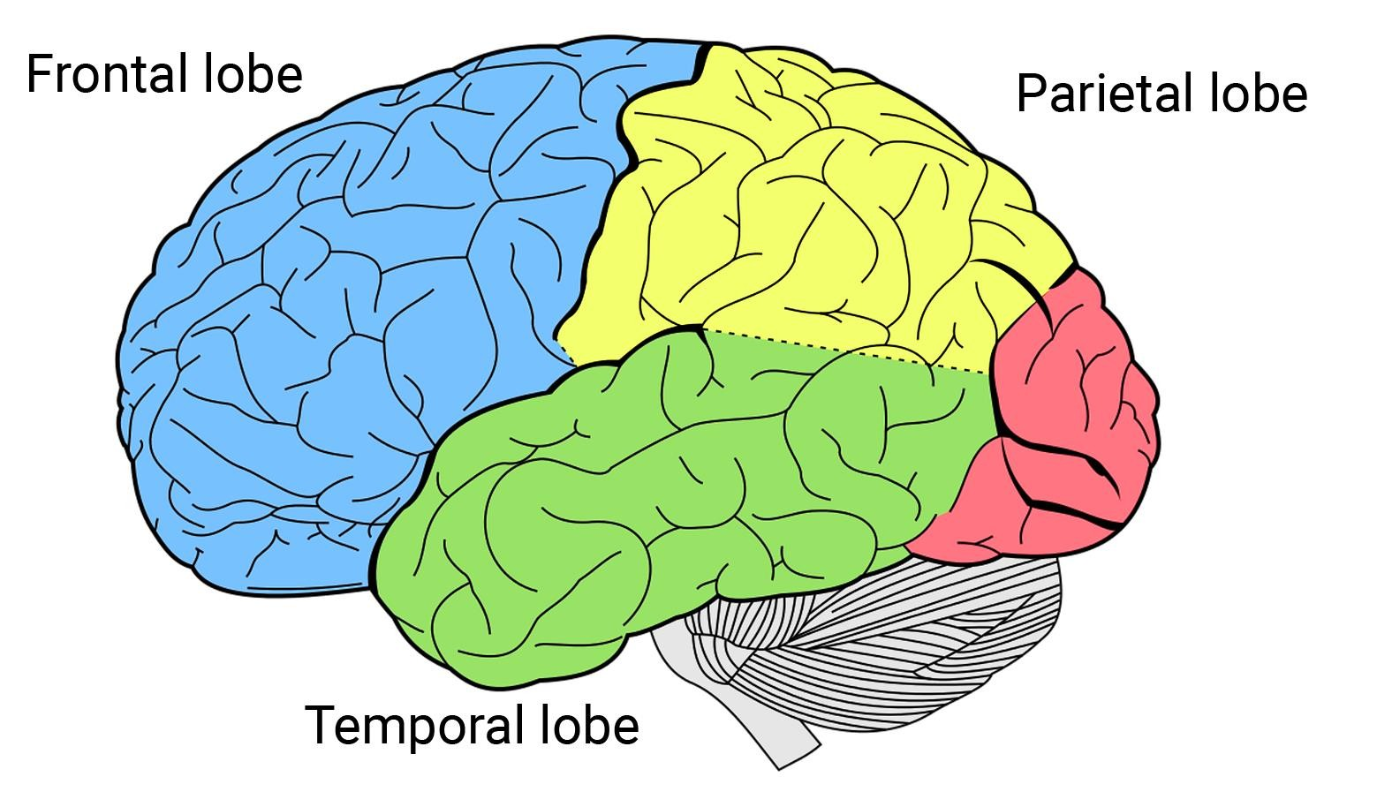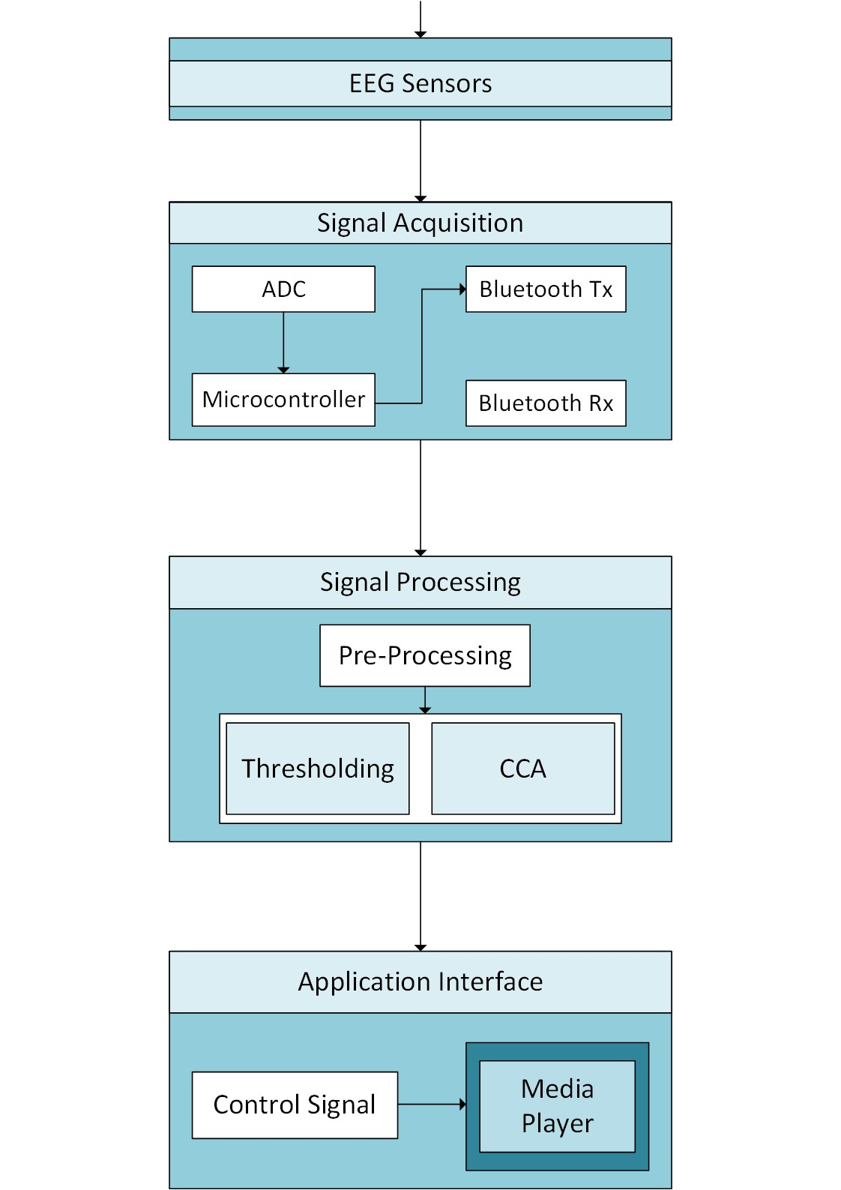

The Media Player can be controlled using following

three modalities:

**Alpha**: EEG signals that correspond to oscillations in

the 8-12 Hz frequency band are referred to as alpha

waves and are prominently observed in the posterior

region of the head over the **occipital lobe**. This could

be generated when the awake subject closes eyes.

**Clench**: On clenching teeth, there is a burst of activity

in the EEG signal.

**SSVEP**: Steady State Visually Evoked Potentials (SSVEP) are the component of EEG signal

corresponding to the frequency of the flickering

stimulus (15Hz) that the subject is viewing.

Hence, a given command can be executed by either closing the eyes, clenching, or staring at the flickering stimulus.

Alpha signal:

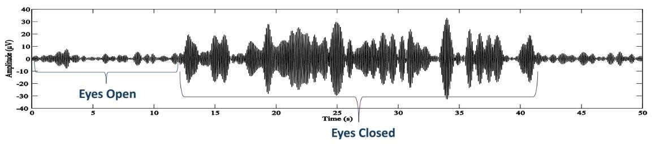

Clench power burst:

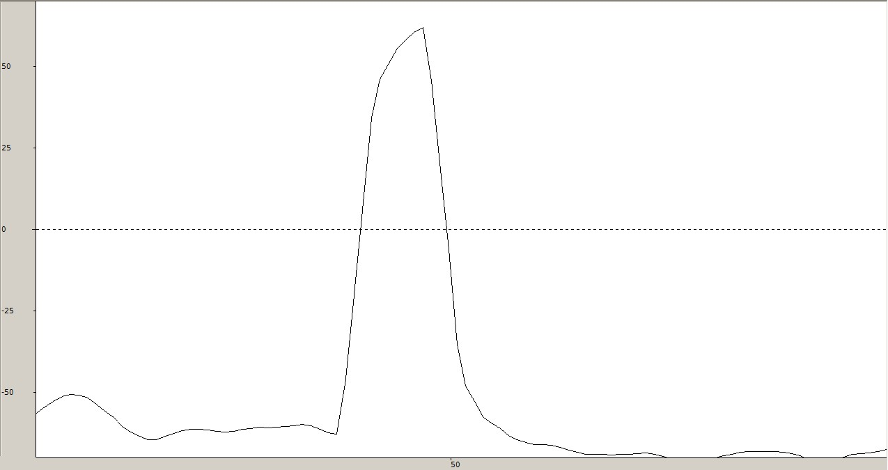

DESCRIPTION



A Brain Computer Interface (BCI) is a direct communication pathway between the brain and an external device. In this project we explore a hybrid non- invasive BCI paradigm using SSVEP and Alpha waves.

GUIDE



Prof. Vidya T.V vidya.tv@pes.edu

SSVEP 15 Hz FFT power spectrum peak:

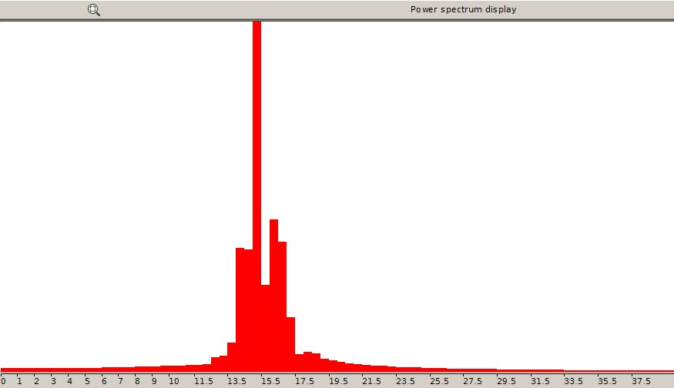

TEAM MEMBERS



Pavan Kumar D. 1PE14EC099

Prashanth H.C 1PE14EC094

Lakshmiraj R. 1PE14EC412

Sawan S.M 1PE14EC128